 | 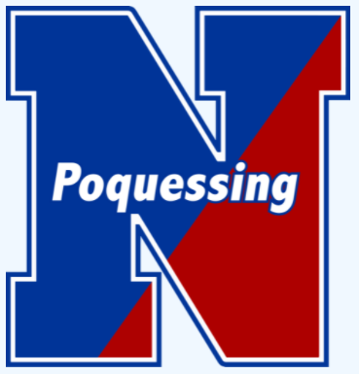

Ms. Karen Pruss, BCIT Teacher | Welcome Back to School – 2024-25

5th Grade: 21st Century Tools Course Overview
Welcome to the exciting world of computer science! I’m thrilled to introduce your child to this new learning adventure in our 21st Century Tools class. This course is designed to equip students with the basics of computer science, including Scratch programming and computer fundamentals. These skills are essential for the digital world and will help foster creativity, critical thinking, and problem-solving.
  Learning Focus | 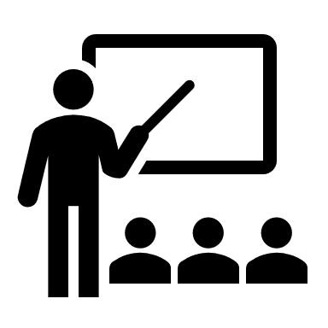  Class Structure
- Computer Basics: Foundations of computer science including hardware, software, email, online safety, and Google tools.  - Financial Literacy: Middle school is an important time to instill smart money management skills through a basic foundation of financial literacy.  - Scratch Coding: Students use Scratch to code their own interactive stories, animations, and games. In the proves, they learn to think creatively, reason systematically, and work collaboratively – essential skills for everyone in today’s society.   Contact:  Email:  215-809-7674 kpruss@neshaminy.org | • Specials Rotation: One of five “specials” (STEM, physical education, art, music, 21st Century Tools) that runs for 36 consecutive days, called quints.  • Canvas Learning Management System: All lessons and assignments are available on Canvas, Neshaminy’s learning management system. If your child misses a class, they can catch up through the digital modules on Canvas.  Resubmissions Encouraged: Students can resubmit assignments for regrading without penalty. This process helps reinforce learning and allows time for correcting mistakes, which is a key part of education.

